**Tekton Pipeline using Docker For Clone and Build**

Tekton is **a powerful yet flexible Kubernetes-native open source framework for creating continuous integration and delivery (CI/CD) systems**. It lets you build, test, and deploy across multiple cloud providers or on-premises systems by abstracting away the underlying implementation details.

**Step1:** First Step is to install DockerDesktop and WSL in windows.

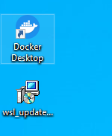

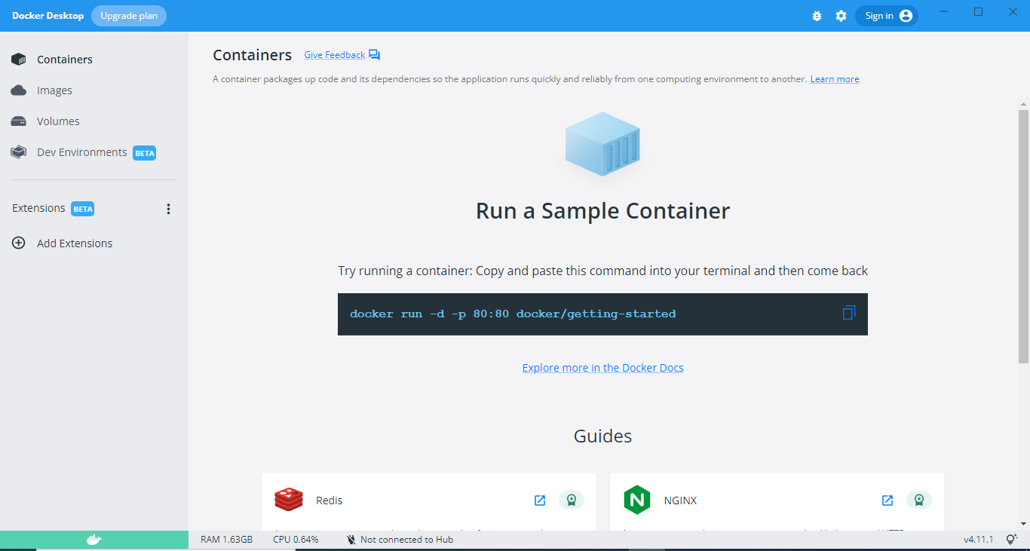

Click on Settings

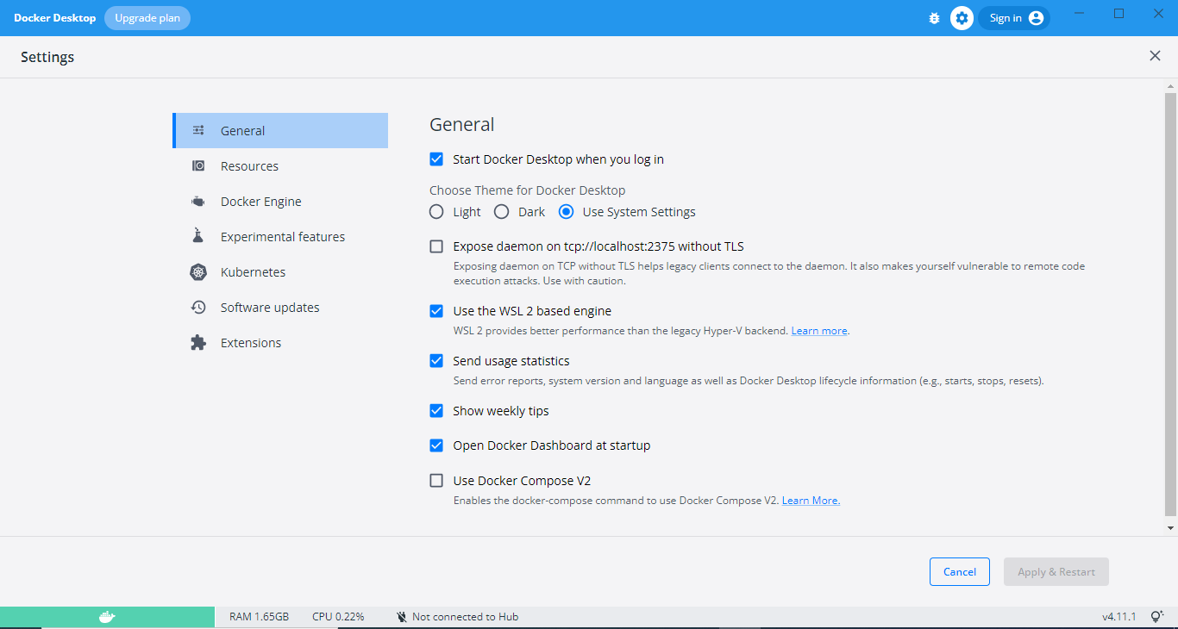

Choose kubernetes in Settings option

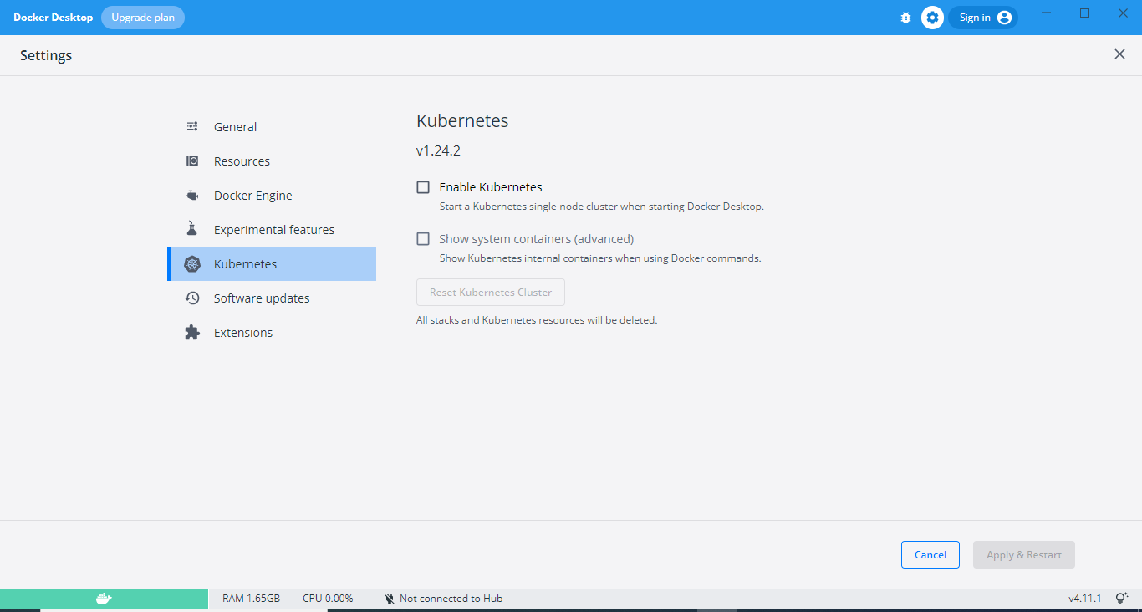

Choose Enable kubernetes and click on Apply & Restart

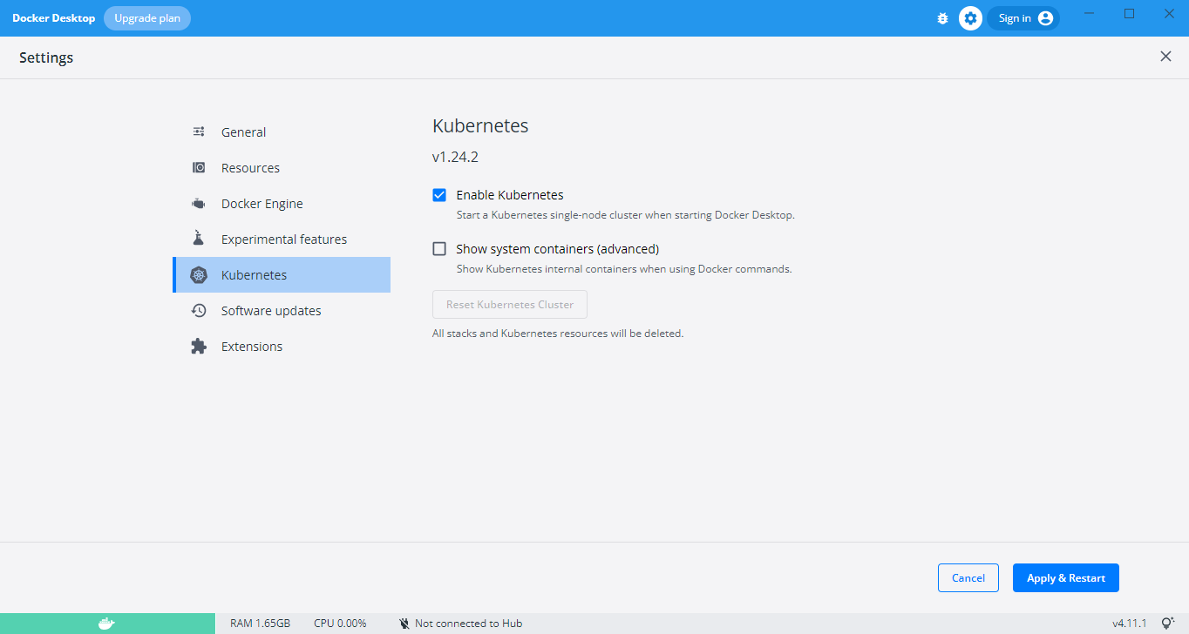

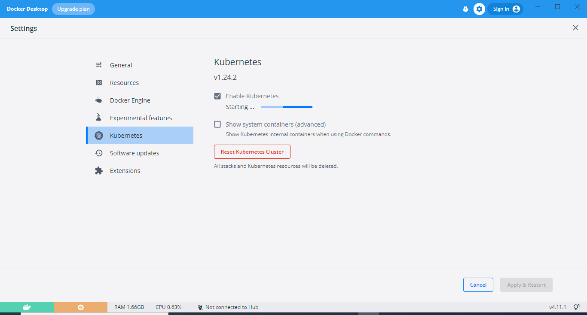

Then the Docker is connected to the kubernetes cluster.

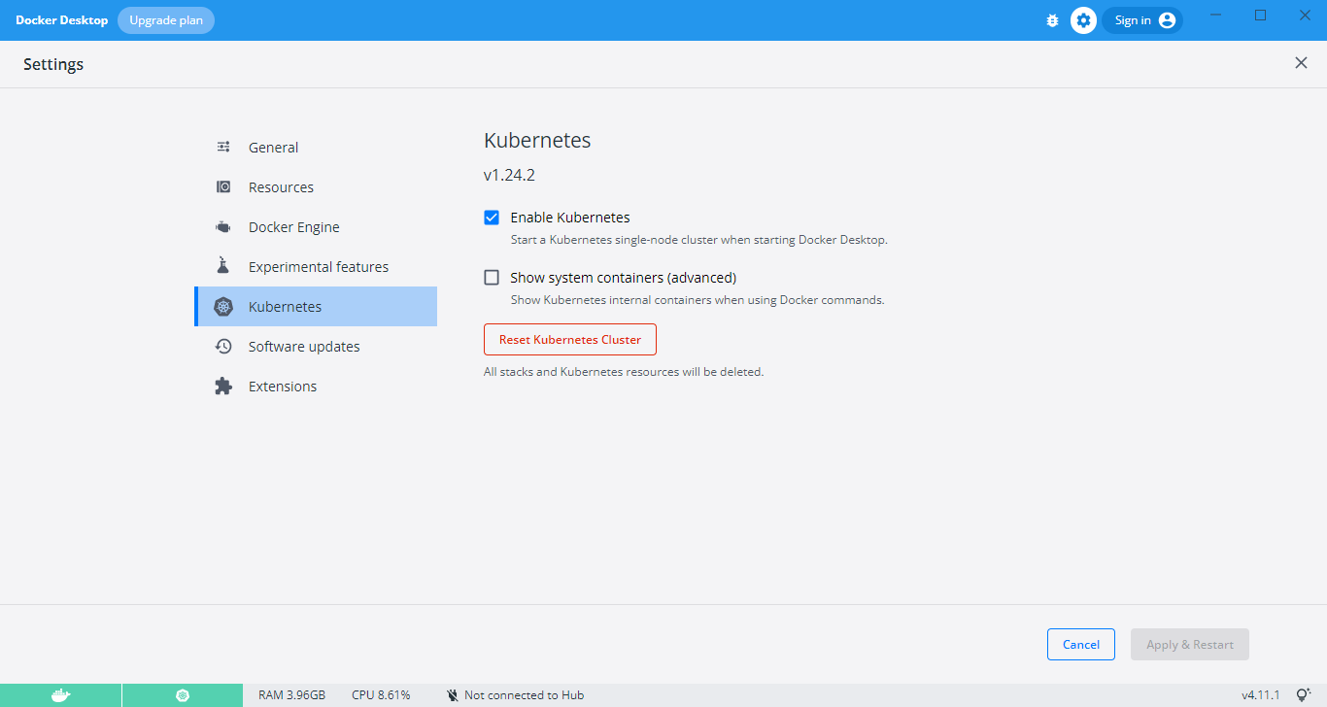

**Step2:** Then need to run the command in powershell for installing minikube for tekton dashboard

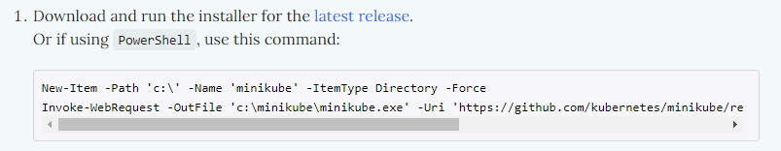

**Command to Run in Powershell:**

New-Item -Path 'c:\' -Name 'minikube' -ItemType Directory -Force

Invoke-WebRequest -OutFile 'c:\minikube\minikube.exe' -Uri 'https://github.com/kubernetes/minikube/releases/latest/download/minikube-windows-amd64.exe' –UseBasicParsing

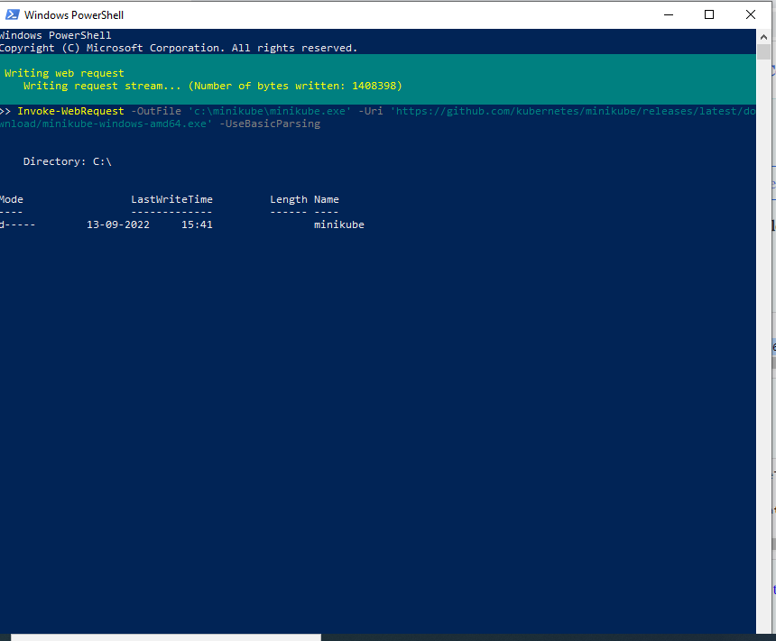

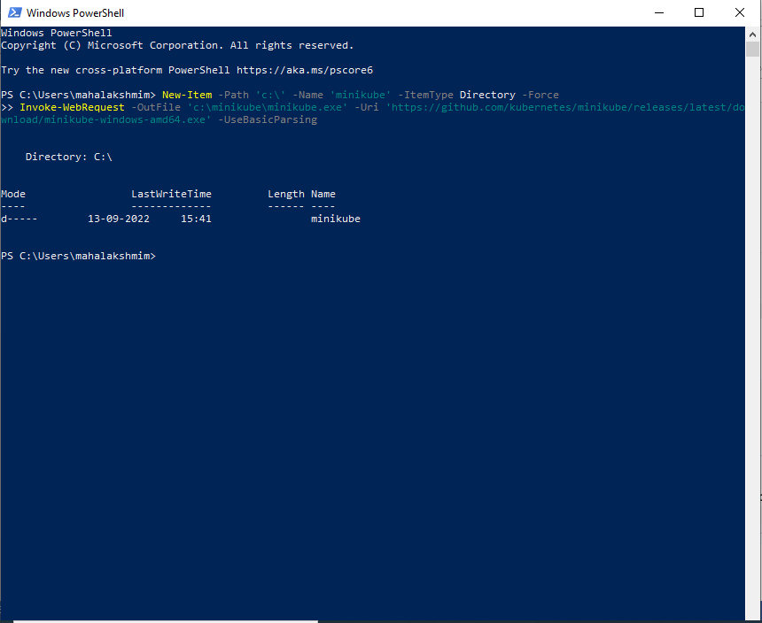

Then go and check in the workspace in LocalDisk (c) minikube will be installed automatically.

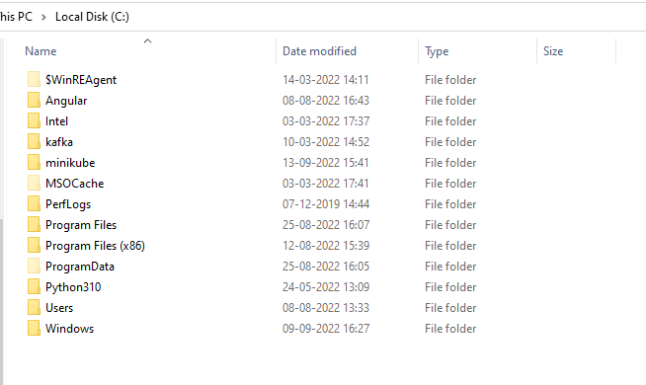

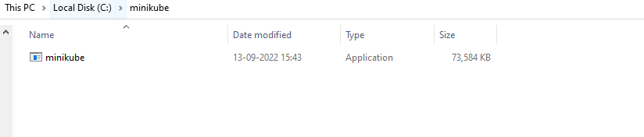

To start the minikube use command **minikube start**

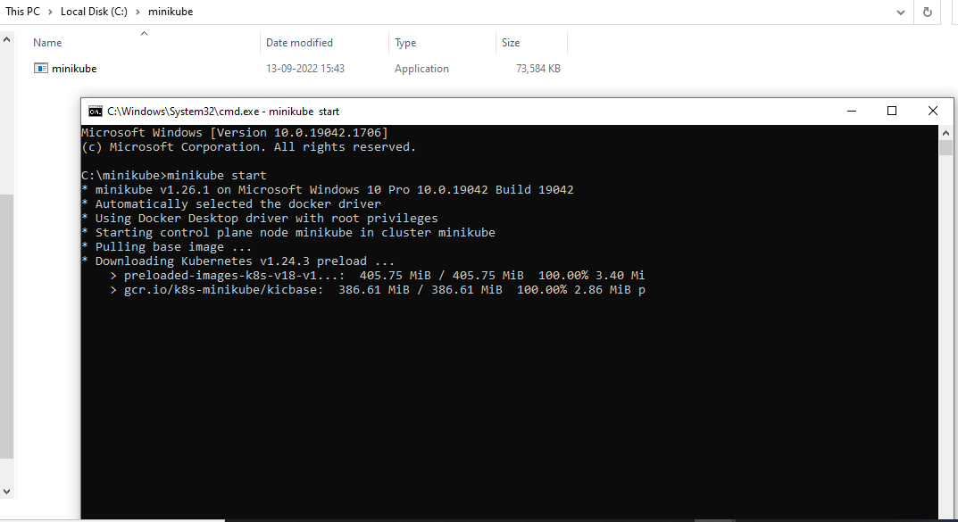

Once minikube started then use some commands to install the configuration settings for tekton.

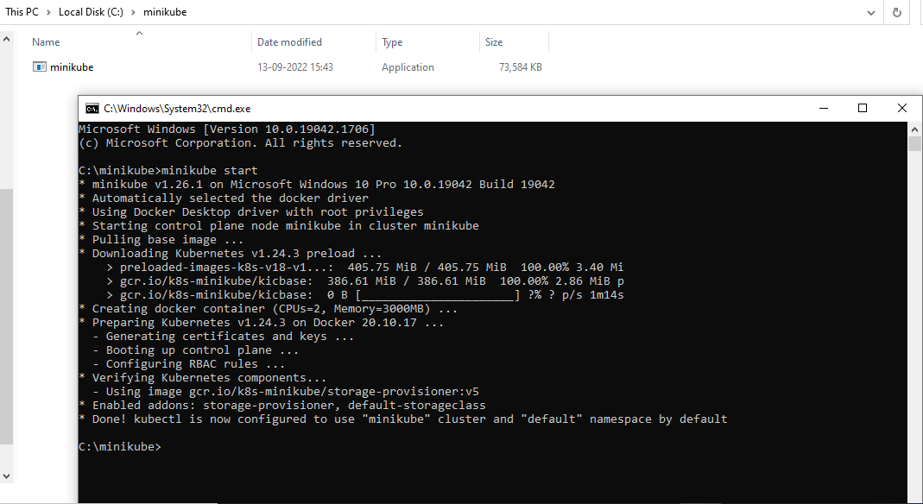

**Step3:** For install tekton in local need to follow the steps

To install tekton pipelines and its dependencies execute

Run: **Kubectl apply –filename** [**https://storage.googleapis.com/tekton-releases/pipeline/latest/release.yaml**](https://storage.googleapis.com/tekton-releases/pipeline/latest/release.yaml)

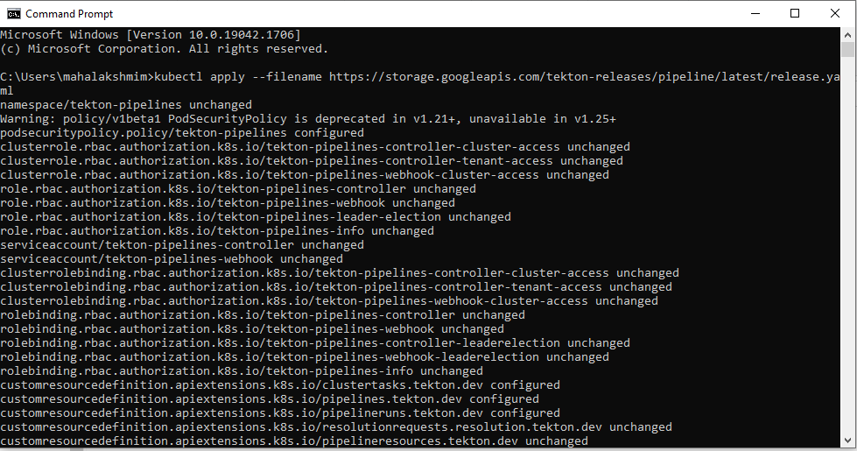

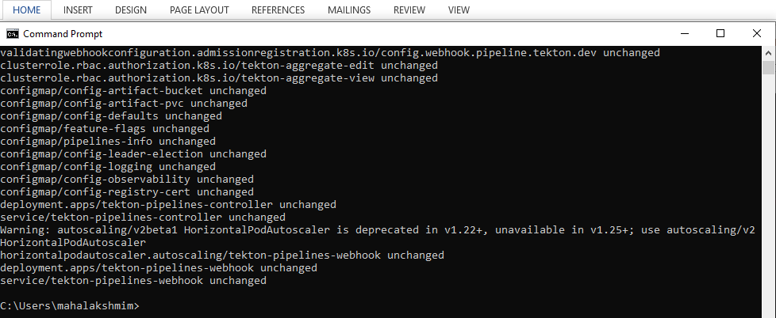

To install tekton dashboard execute **kubectl apply –filename** [**https://github.com/tektoncd/dashboard/releases/latest/download/tekton-dashboard-release.yaml**](https://github.com/tektoncd/dashboard/releases/latest/download/tekton-dashboard-release.yaml)

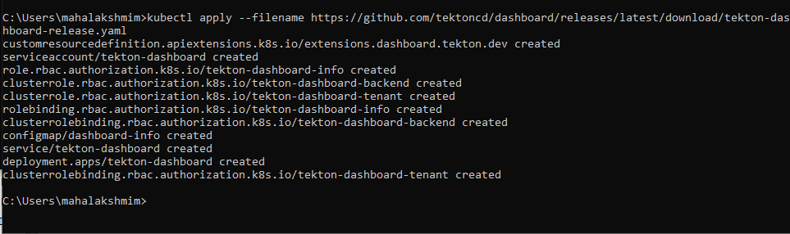

To setup port forwarding with tekton dashboard,execute

**kubectl --namespace tekton-pipelines port-forward svc/tekton-dashboard 9097:9097**

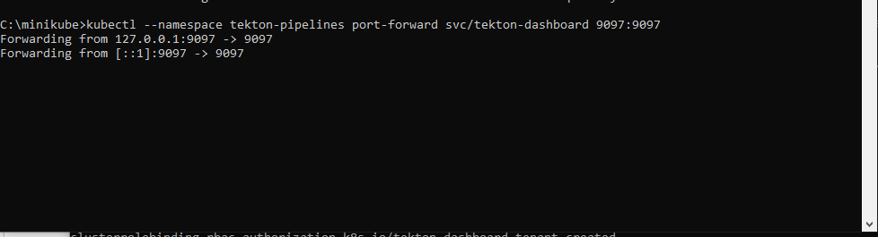

Then check in the browser by using [**http://localhost:9097**](http://localhost:9097) port

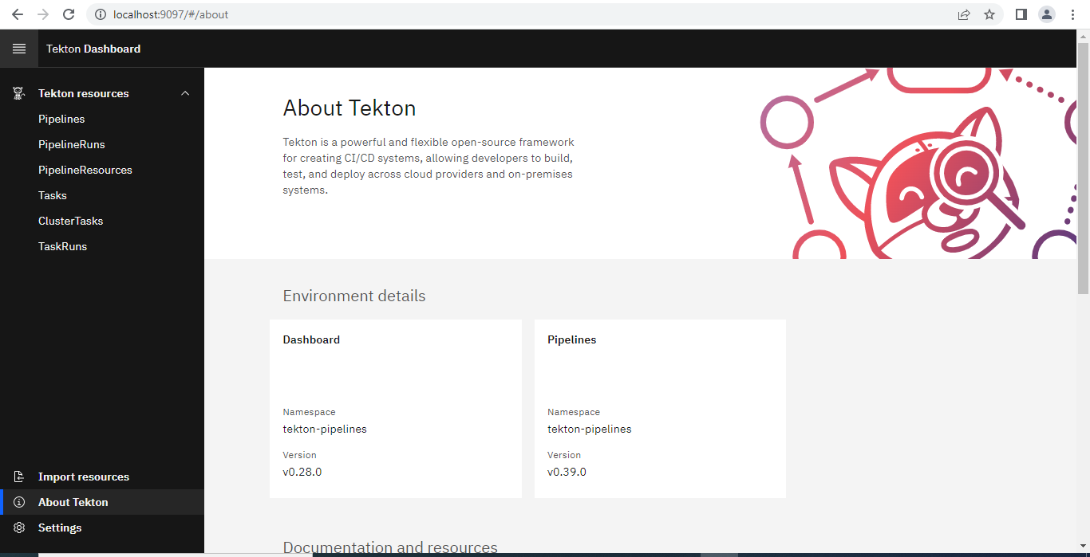

If already have any credential means we use the repository and clone the code in tekton using the import option.

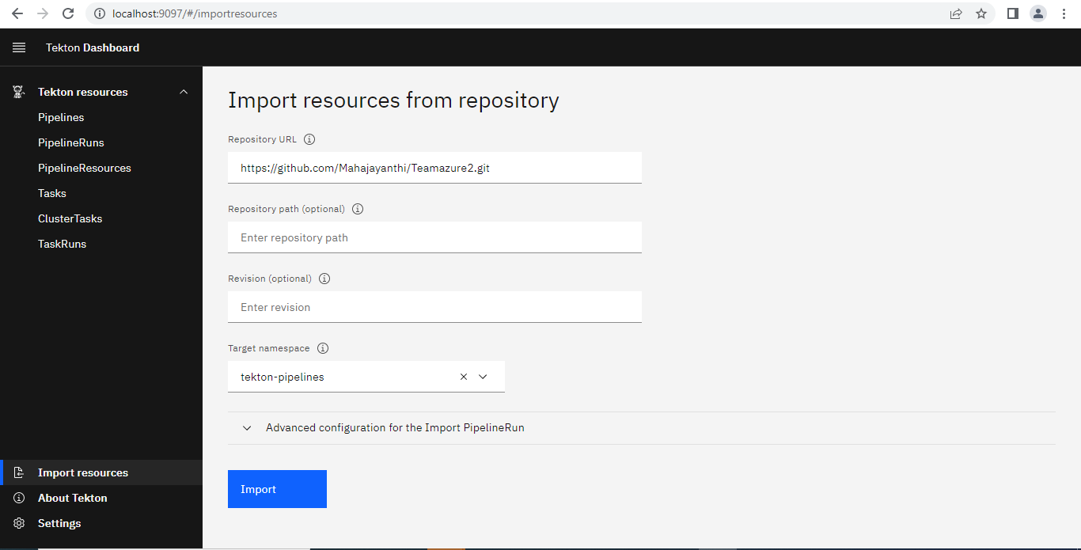

**Step 4:** This was the sample spring boot application with jar file

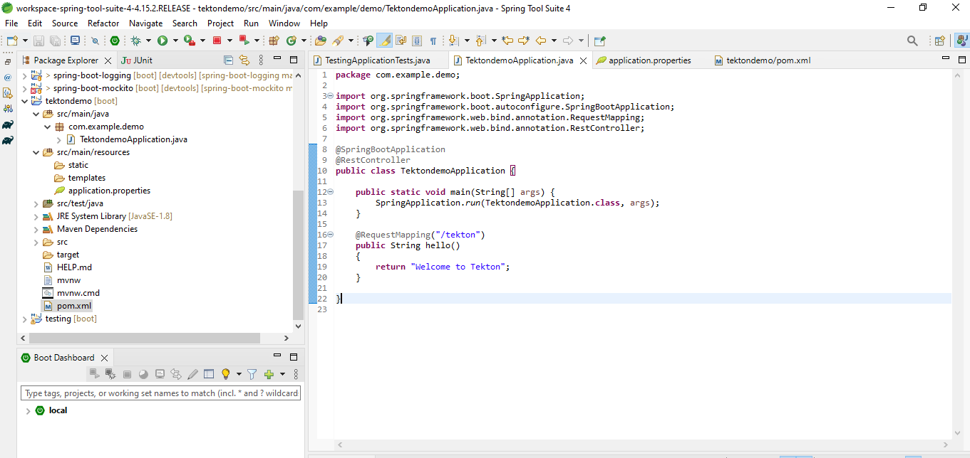

This was the Docker file of the spring boot application with **JDK version , port number and Jar file name.**

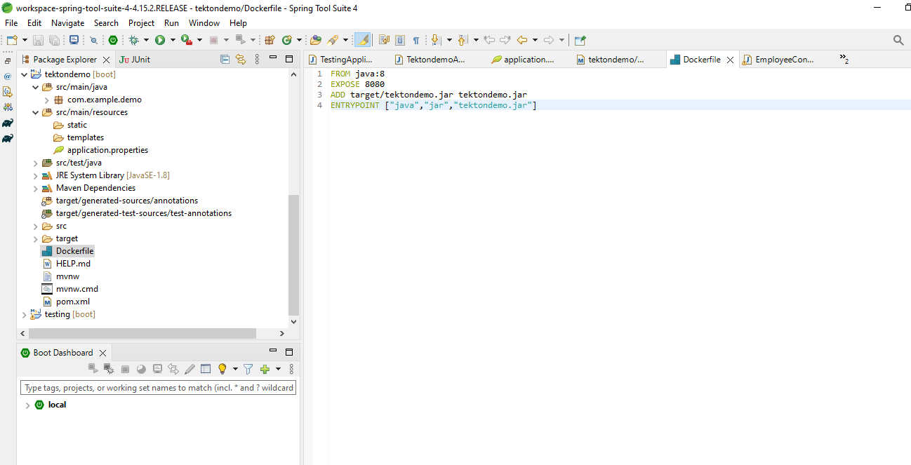

Pom.xml configuration for generating jar file

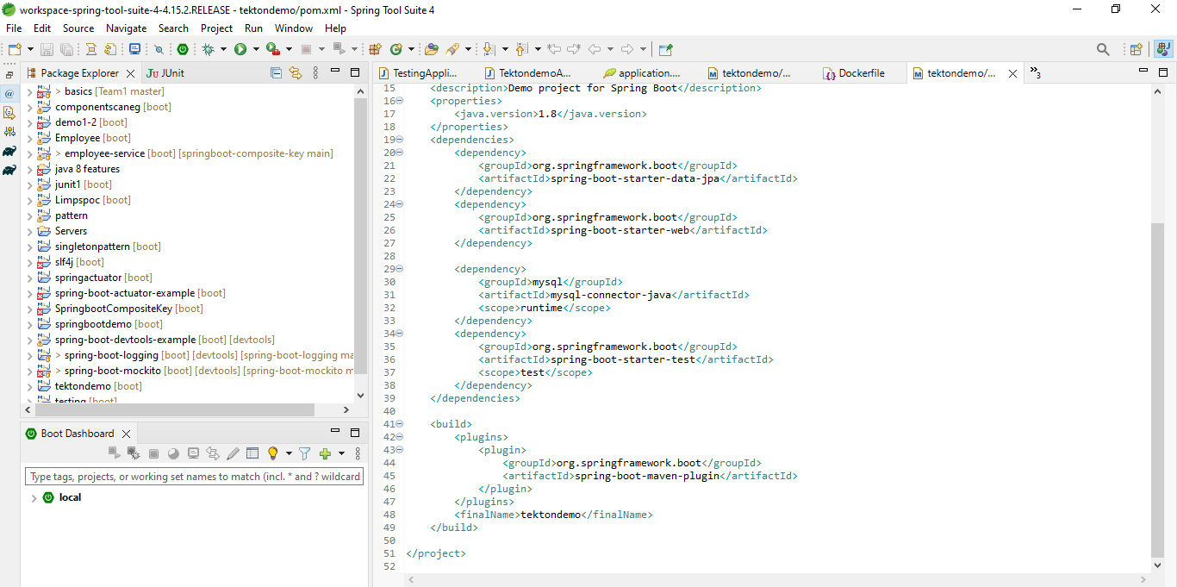

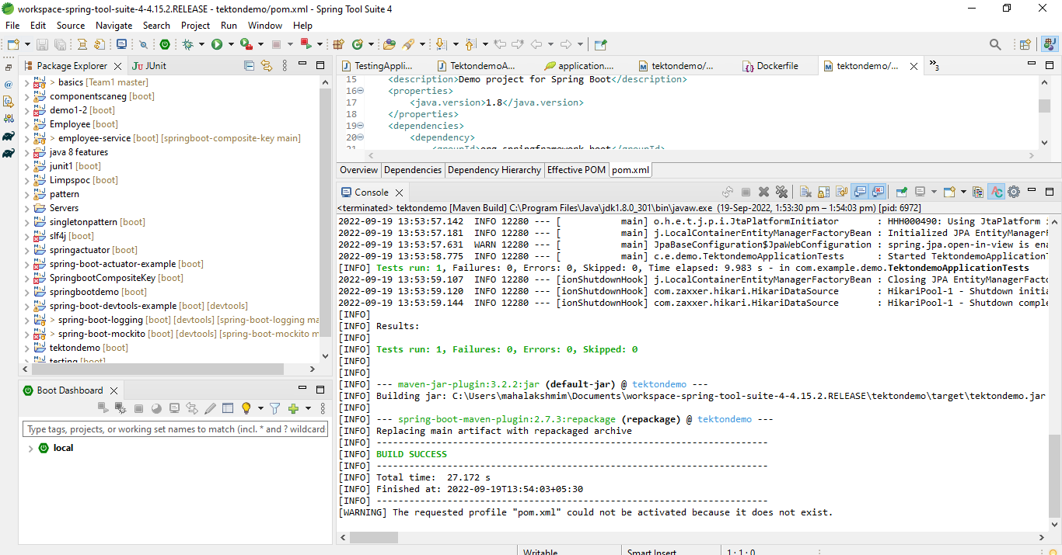

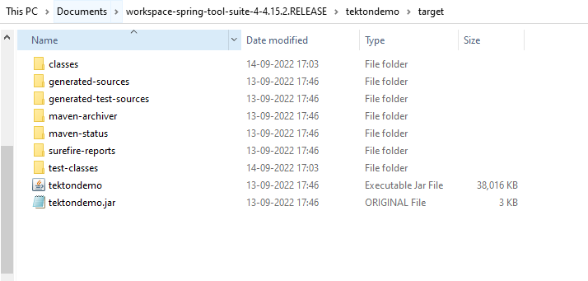

I pushed the code in to my GITHUB.

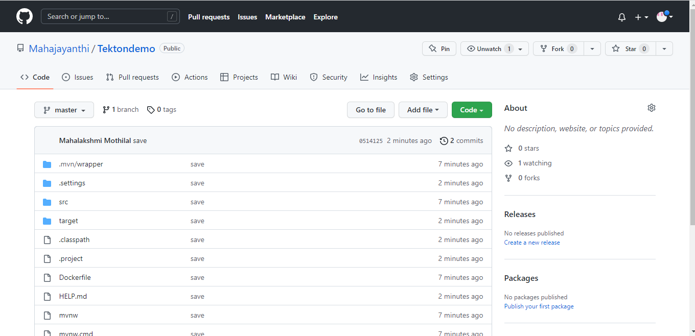

Open the DockerHub page in browser. Then login with Docker desktop username and password.

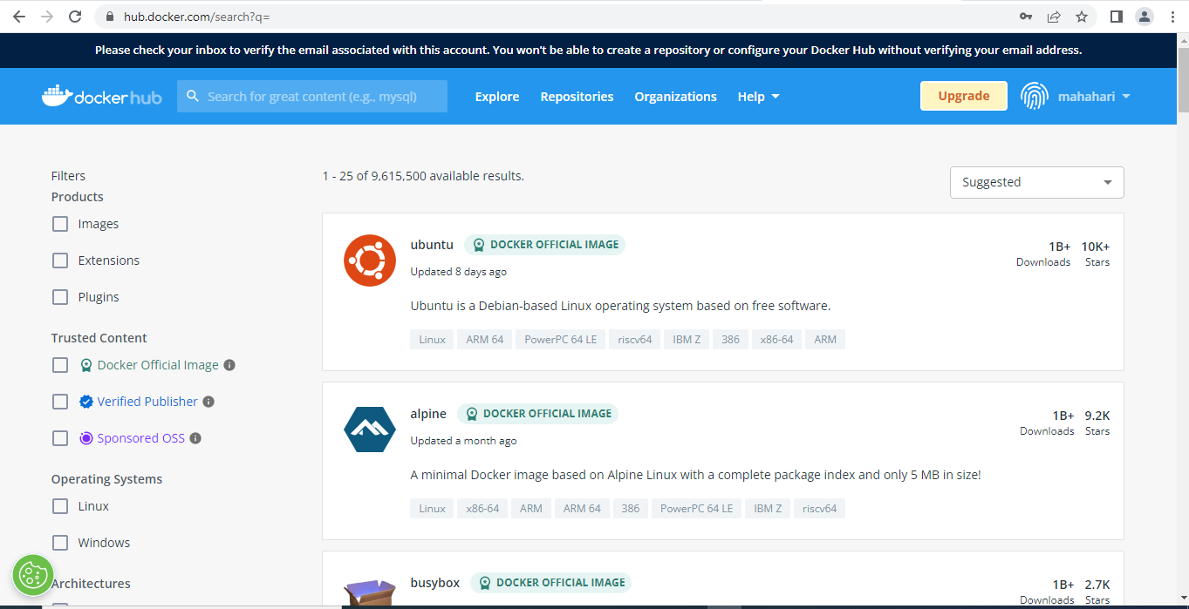

Click on create repository and then create new repository.

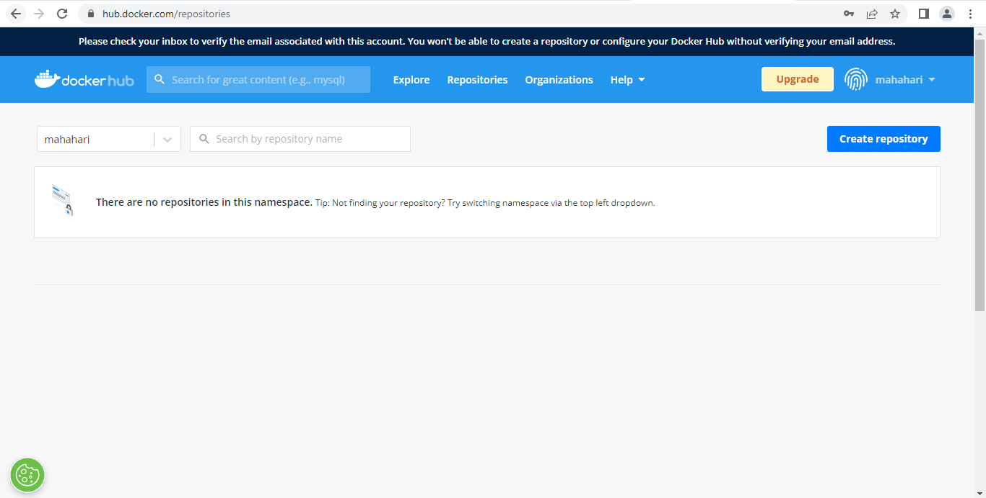

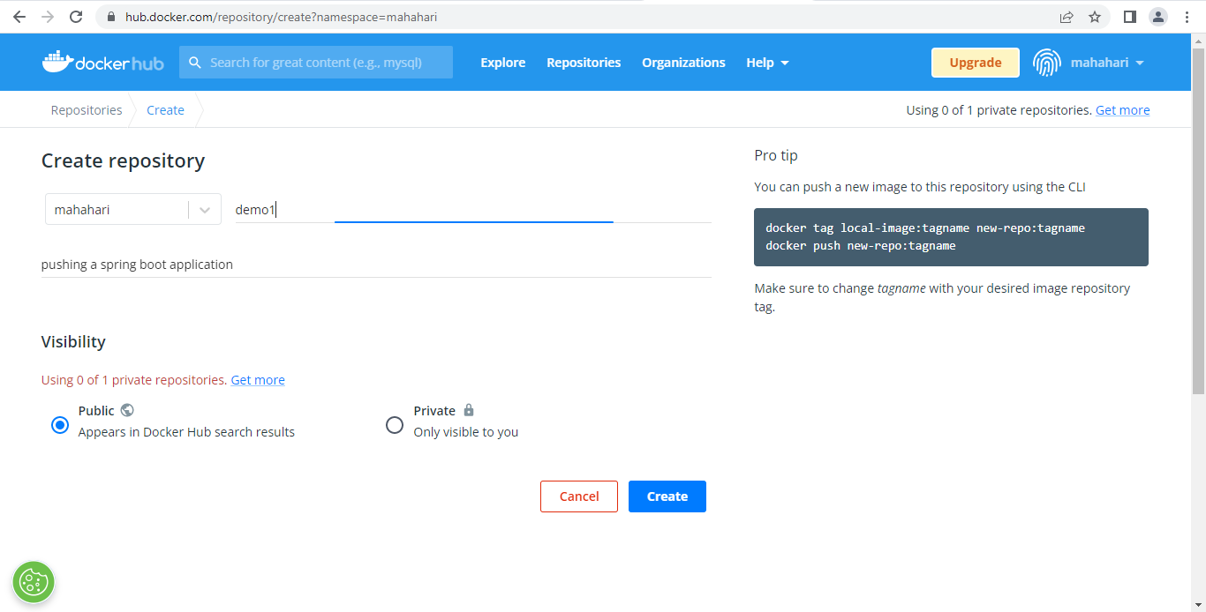

Once the repository is created its look like this.

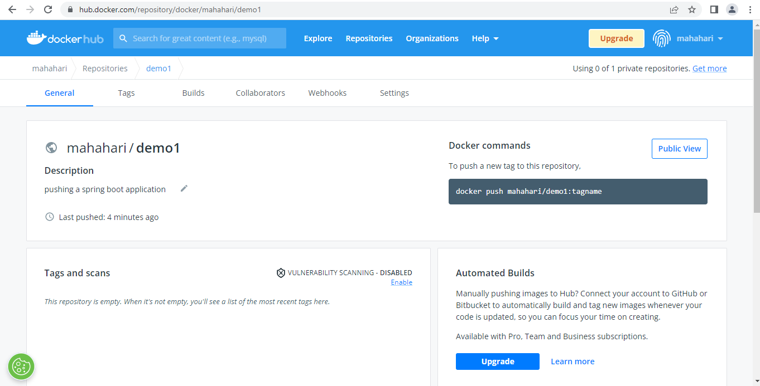

**Step 5:**  For running file in Tekton dashboard we need to run the following the files.

**Docker-secret.yaml**

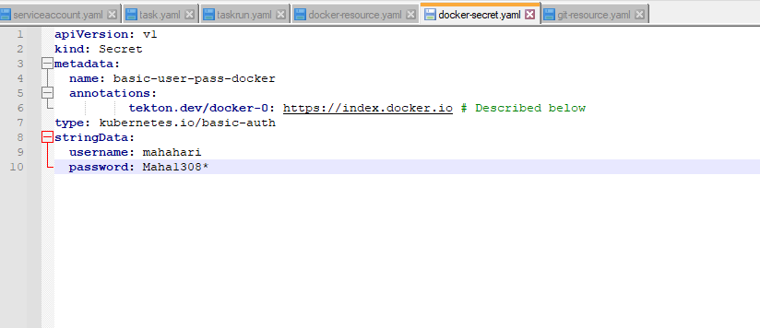

**Serviceaccount.yaml**

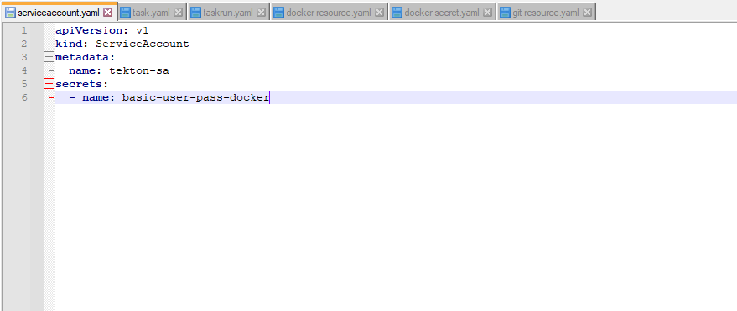**Docker-resource.yaml**

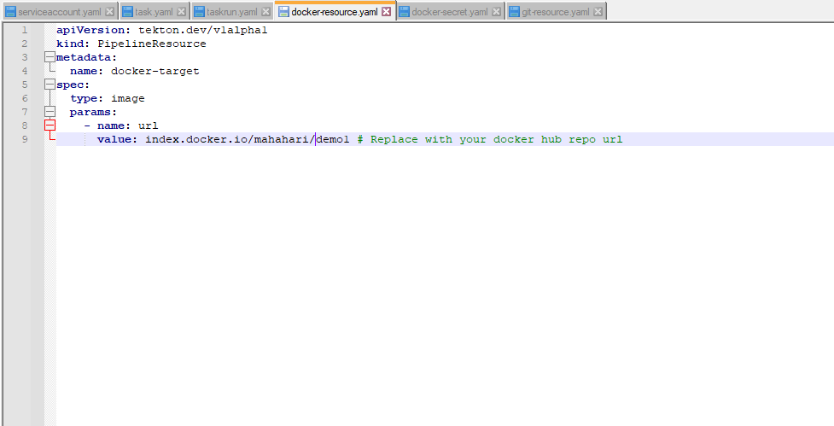

**Git-resource.yaml**

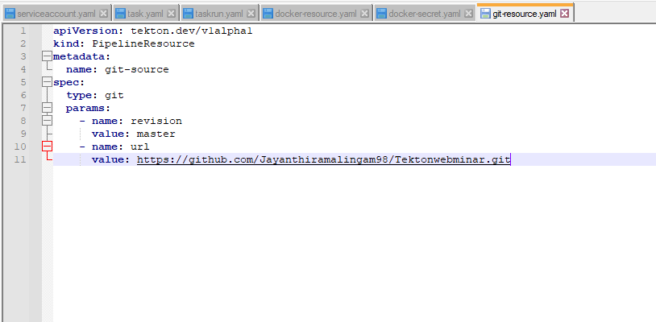

**Task.yaml**

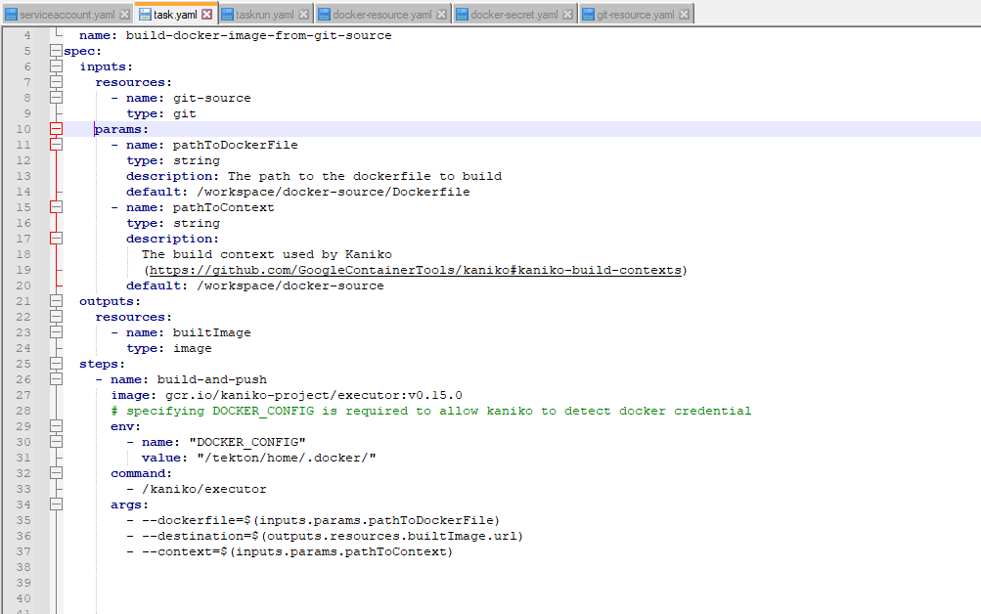

**Task run.yaml**

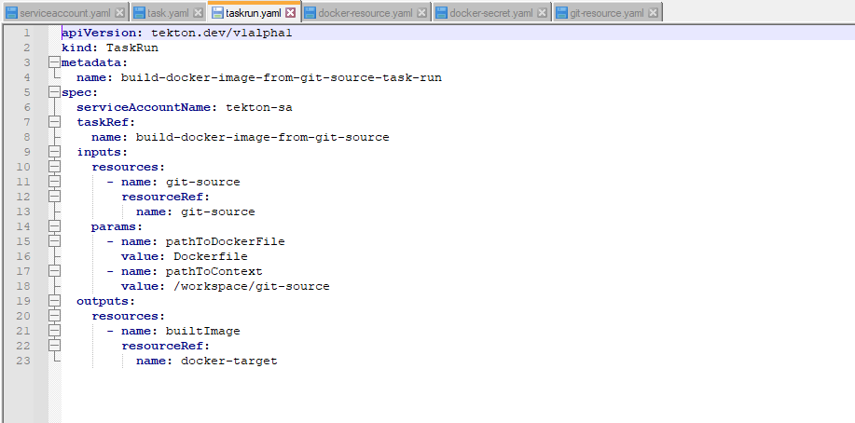

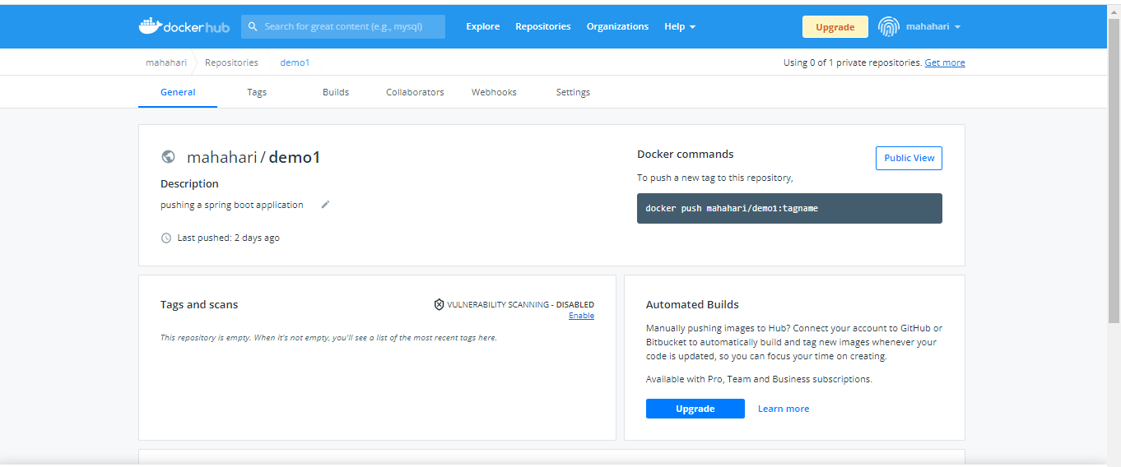

**Step 5:**  Commands to run Build the pipeline in Tekton.

**kubectl apply –f docker-secret.yaml**

**Kubectl apply –f serviceaccount.yaml**

**Kubectl apply –f docker-resource .yaml**

**Kubectl apply –f git-resource.yaml**

**Kubectl apply –f task .yaml**

**Kubectl apply –f taskrun.yaml**

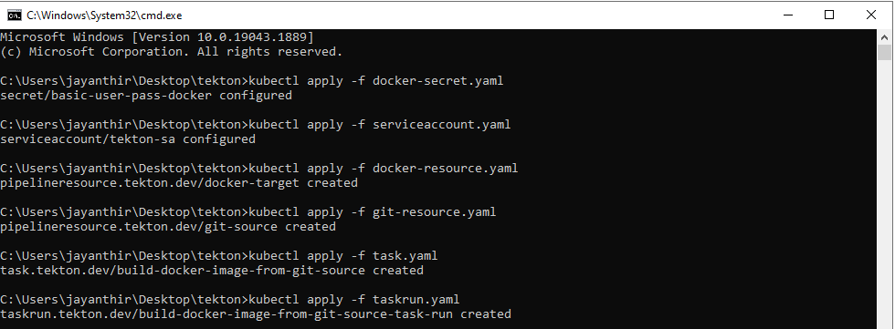

**Step 6:** Pipeline in Tekton dashboard .

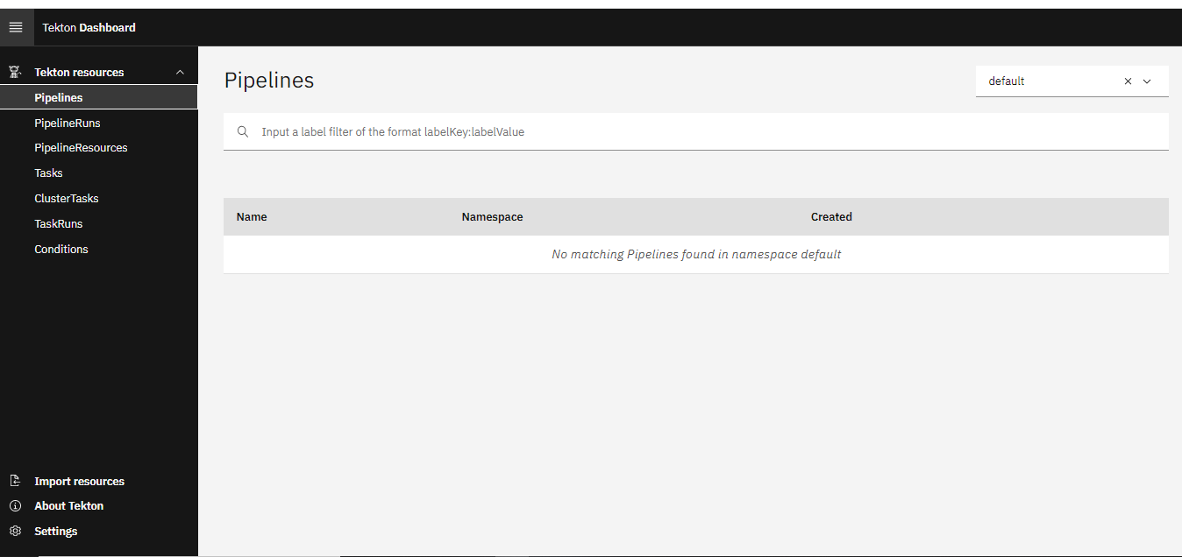

After run the docker-resource and git-resource success we can see the pipeline was generated in this pipelinesResource

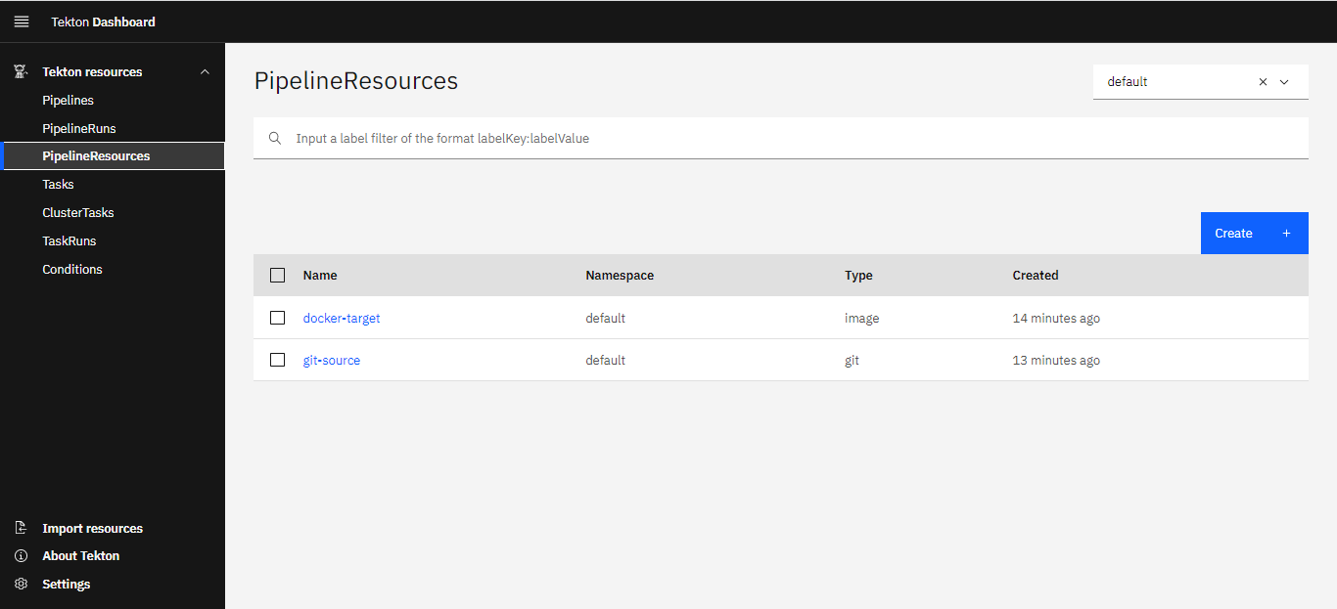

After run the task command success we can see the Task in tekton dashboard

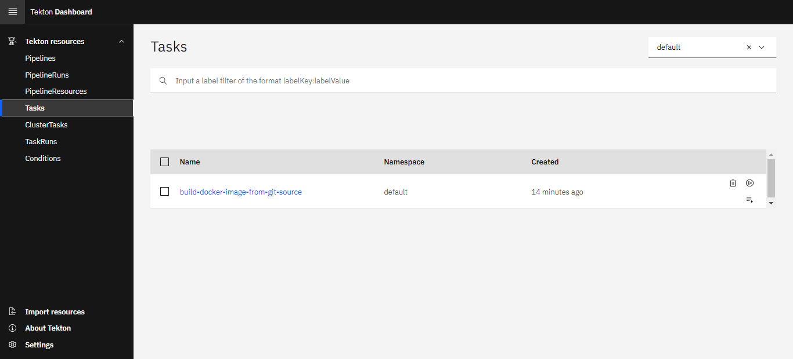

After running the taskrun command success we can see the Taskruns in Tekton dashboard

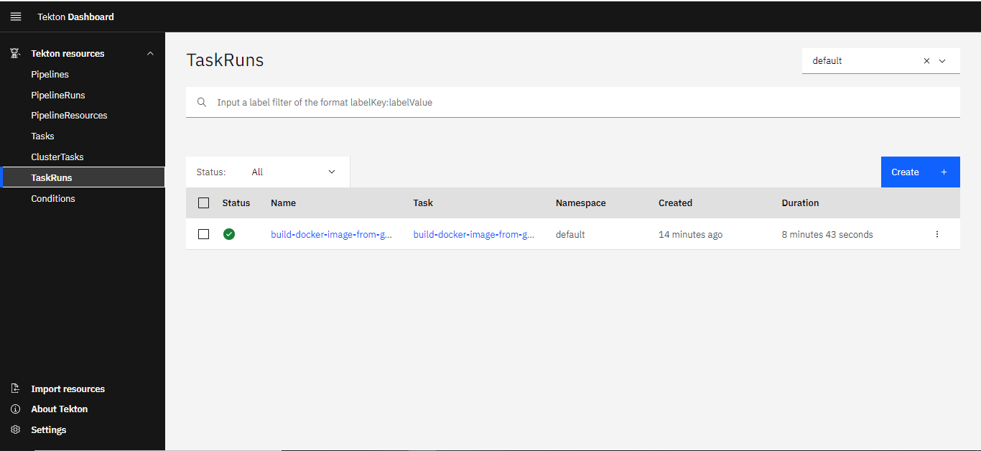

This is the build pipeline in tekton dashboard with step by step process

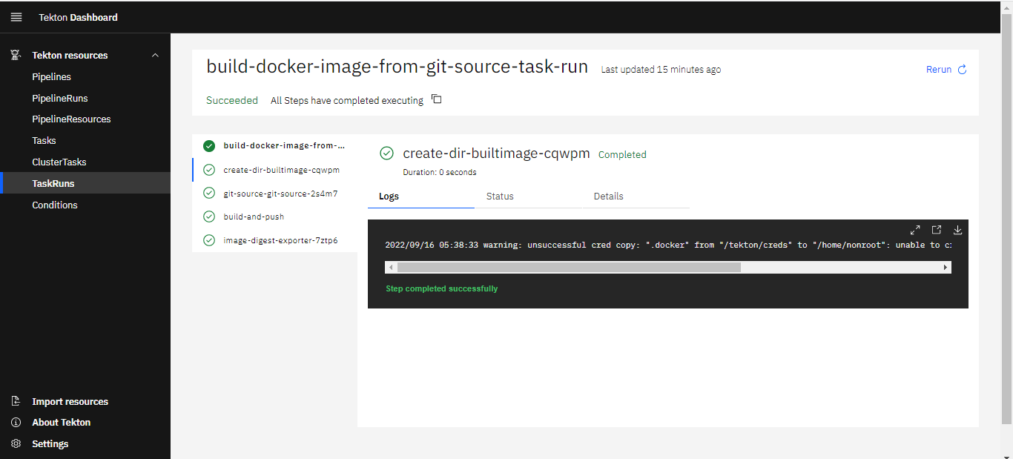

After running all the files we can see the Tag in Dockerhub

